The title : Social isolation

The next line : King Fahd university of petroleum and minerals

Before starting questions and after asking the name of the student 👇🏻write this

I hope you can help us by answering the following 10 questions so that we can measure your social level and help you improve it.

Q1: I doubt the benefit of forming social relationship

Often(2)  Sometimes(1)  Never(0)

Q2: I prefer to solve my problems by myself, even if it takes a long time to solve, rather than ask someone to help me with them.

Often(2)  Sometimes(1)  Never(0)

Q3: I have relationships with people who are very good at understanding me

yes(0) I am not sure of this (1)  No (2)

Q4: I can be good at finding the right friends when I don’t have them.

yes(0) I am not sure of this (1)  No (2)

Q5: I lack constructive social relationships that connect me with others

Often(2)  Sometimes(1)  Never(0)

Q6: I lack the confidence that would make me enter into relationships with others

Often(2)  Sometimes(1)  Never(0)

Q7: I feel overwhelmed by the desire to isolate myself and spend time alone most of the time

Often(2)  Sometimes(1)  Never(0)

Q8: I think a lot before starting a conversation with a new person, and sometimes I can't

Often(2)  Sometimes(1)  Never(0)

Q9: I apologize for not going to most meetings and events in order to spend time improving my academic level

Often(2)  Sometimes(1)  Never(0)

Q10: I do not make an effort to form relationships during university years , and I only put my effort into my studies

Often(2)  Sometimes(1)  Never(0)

Ranges :

(0-2) points you are …..

(3-5) points you are …..

(6-8) points you are …..

(9-20) points you are ….

I want this sign to be in all pages at the up left corner

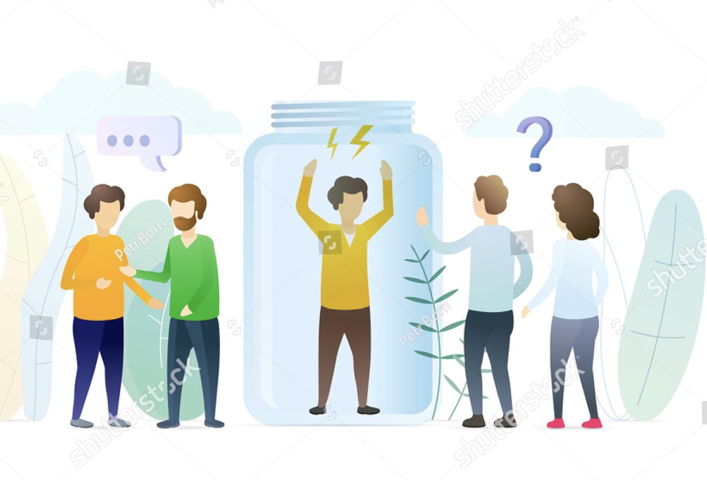And I want this to be at the down right corner in all pages ( I want to be big)